# Analysis Report for not emotional, static conversation.docx

not emotional, static conversation.docx Analysis Report:  
---------------------  
affective_score: 20.00  
animate_score: 0.00  
commonality_score: 61.34  
cognitive_score: 0.00  
directness_score: 0.00  
dynamic_score: 0.00  
formality_score: 0.00  
generic_score: 0.00  
inanimate_score: 100.00  
individual_score: 0.00  
informality_score: 0.00  
intentional_score: 0.00  
longterm_score: 0.00  
negative_score: 0.00  
novelty_score: 70.10  
objectivity_score: 0.00  
place_score: 0.00  
politeness_score: 100.00  
positivity_score: 100.00  
qualitative_score: 0.00  
quantitative_score: 0.51  
short_term_score: 70.06  
social_score: 70.12  
specific_score: 70.00  
static_score: 70.00  
temporal_score: 70.13  
  
## Synergy Analysis:  
**Warning:** Missing dimension scores for Affective, Cognitive, Dynamic, Social, Novelty, Time, Positive, Negative, Intentionality, Formality, Specific, Static, Quantitative, Politeness. Synergy analysis may be incomplete.  
Overall Interpretation:  
The text shows strong indications in the following dimensions:  
- inanimate_score (Score: 100.00)  
- politeness_score (Score: 100.00)  
- positivity_score (Score: 100.00)  
  
The text shows weaker indications in the following dimensions:  
- objectivity_score (Score: 0.00)  
- place_score (Score: 0.00)  
- qualitative_score (Score: 0.00)  
  
Analysis Method Used: Advanced  
Interpretations are based on the dimension scores calculated using the selected method.

## Radar Chart for This Input

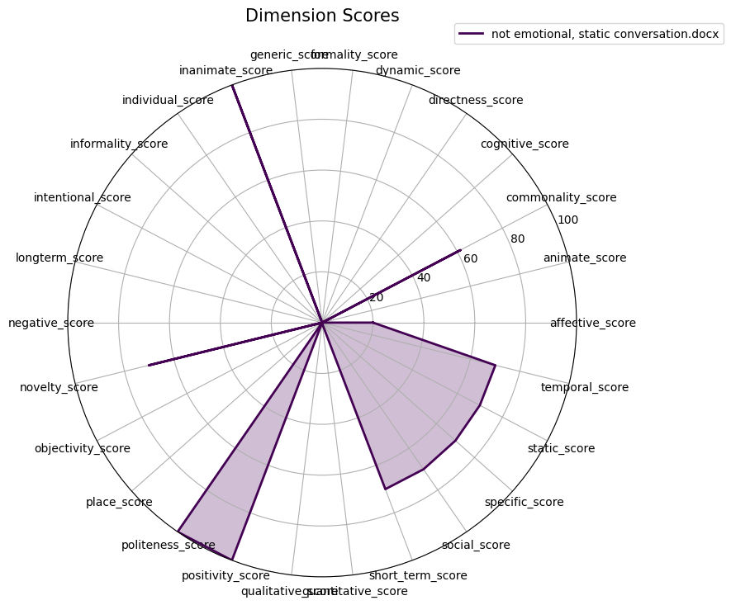

## Combined Radar Chart for All Inputs

